Elasticity in Economics
Elasticity is an important concept in economics. It is used to measure how responsive demand (or supply) is in response to changes in another variable (such as price).

Price Elasticity of Demand
The most common elasticity, is price elasticity of demand. This measures how demand changes in response to a change in price.
Questions on Elasticity
- If the price of salt increases, will you reduce demand for salt?
- If the price of Akmina mineral water increases, would you reduce demand for Akmina?
- If the price of electricity increases, would you reduce demand?
- If the price of a Vodaphone mobile phone increased, would you still buy it?
All these questions relate to the issue of elasticity. Some goods like salt are price inelastic because if the price of salt increases, people will generally keep buying it. e.g. a 10% increase in price, may reduced demand for salt by only 1%.
We say the PED of salt is -1/10 = -0.1
However, if the price of Akmina mineral water increased by 10%, many consumers would buy other types of mineral water. This is because Akmina mineral water has many substitutes – Sırma, Uludağ, Özkaynak etc
Therefore, a 10% increase in the price of Akmina water may reduce demand by 18%. Therefore, the PED of Akmina is -18/10 = -1.8. We say that Akmina has an elastic demand – it is sensitive to changes in price.
Price Inelastic demand.
We say demand is inelastic if a change in prices causes a smaller % fall in demand. Examples, include
- Petrol (10 lira da olsa bineriz arabalara)
- salt
- Tobacco
- Electricity
- Gas
All these goods are seen as necessary by consumers. If the price of electricity goes up, you will still use it to turn on lights and your TV. You can’t plug your TV into the gas socket. Electricity is inelastic because it doesn’t have any close substitutes. It is the same for petrol and salt.
Firms with monopoly power will face an inelastic demand curve.
Elastic Goods
This means a change in price leads to a bigger % change in demand. Elastic goods will be anything with many substitutes or luxury items that are expensive to buy e.g.
- IHE Bread, Marmara Simit
- Iphone 11, Ipad
- Jeep, Porsche
- Designer label Clothes, Network Zara
Therefore, a firm could cut price and gain a bigger % increase in demand. These are goods with many substitutes. E.g. if ERIKLI cut its price by 10%, it may gain an 18% increase in market share (unless other firms also cut prices)

Using Knowledge of Elasticity
If a firm knows that demand for its product is price inelastic, then it can increase price and lead to an increase in revenue. Generally, firms would seek to make their goods more price inelastic, through advertising and highlighting unique selling point.

TOTAL REVENUE = P X Q

The Midpoint Method: A Better Way to Calculate Percentage Changes and Elasticities

MID TERM QUESTION !!!
- The midpoint formula is preferable when calculating the price elasticity of demand because it gives the same answer regardless of the direction of the change.

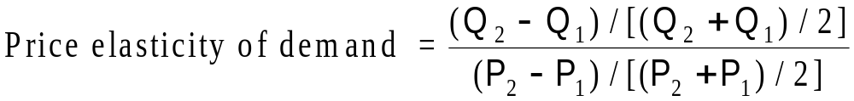

- Example: If the price of M&Ms increases from 2.00 TL to 2.20 TL and the amount you buy falls from 10 to 8 packages, then your elasticity of demand, using the midpoint formula, would be calculated as:

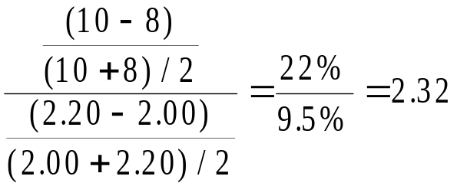

SO THE DEMAND IS ELASTIC because >1

IN THE EXAM YOU WILL BE ASKED TO DRAW THE GRAPH TOO !!!

ABSOLUTE VALUE IS USED
- Inelastic Demand
  - Quantity demanded does not respond strongly to price changes.
  - Price elasticity of demand is less than one.
- Elastic Demand
  - Quantity demanded responds strongly to changes in price.
  - Price elasticity of demand is greater than one

ANOTHER EXAMPLE :

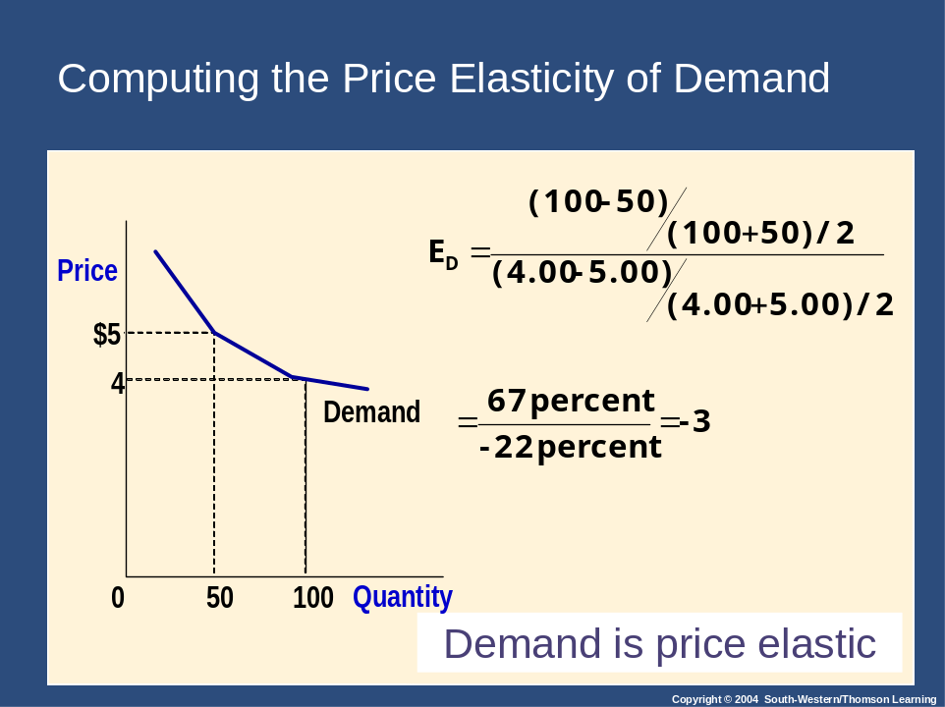

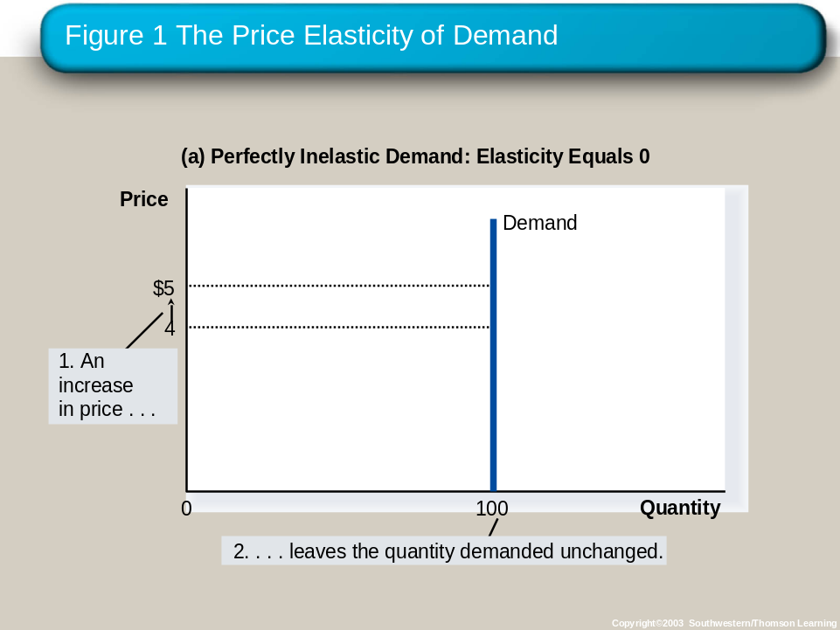

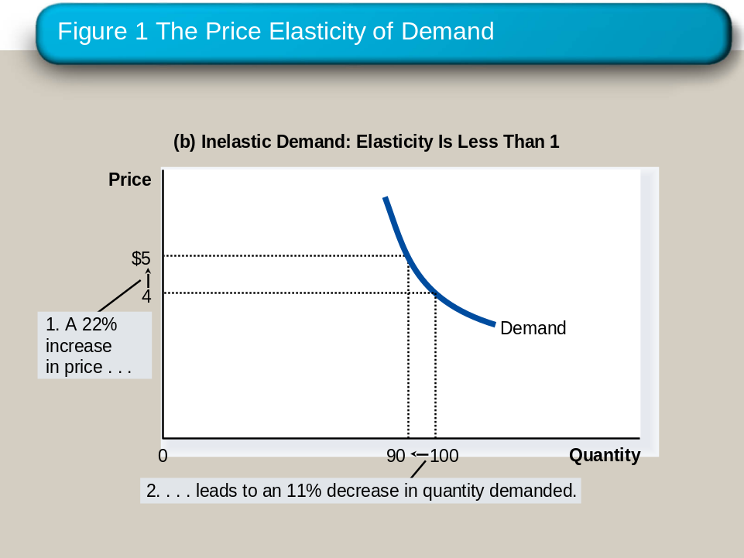

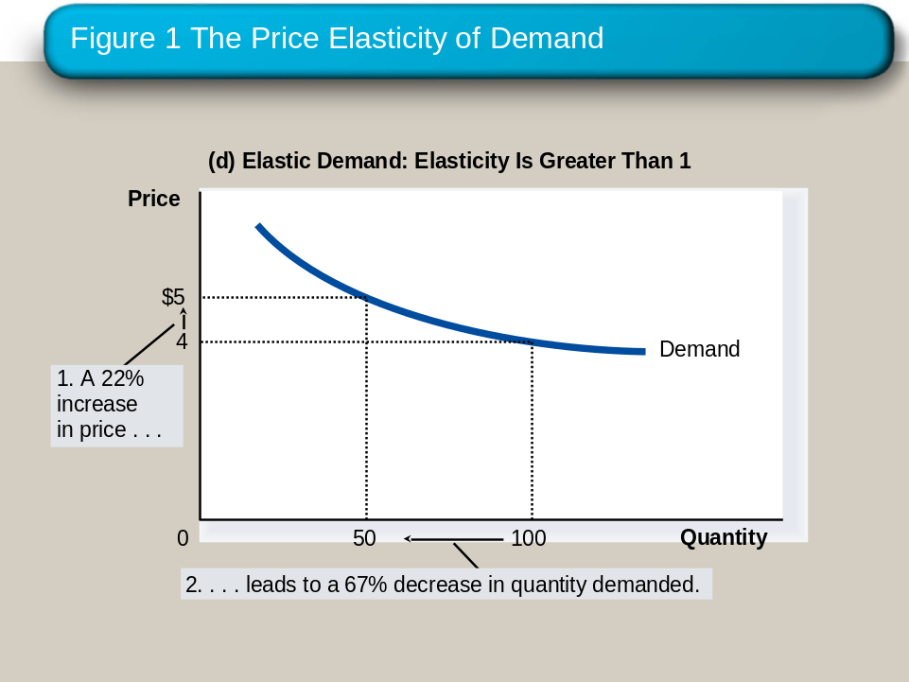

TOTAL REVENUE :
IN INELASTIC DEMAND

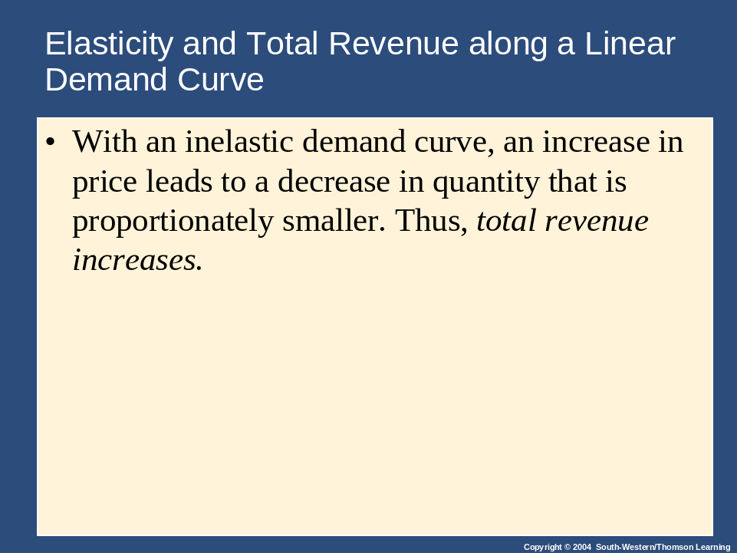

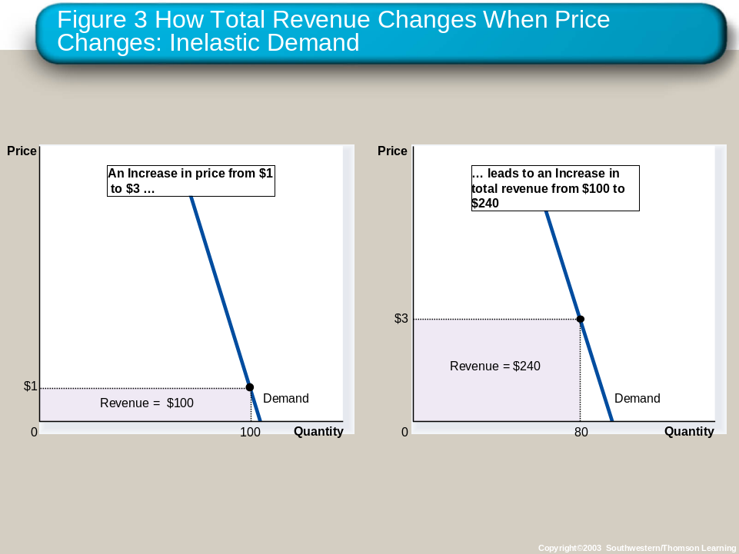

IN ELASTIC DEMAND

